Standard PPE Requirements For Department

Steel toe cap footwear is required for the department operation, whether these be in the form of boots or shoes, both are acceptable. Please contact you production manager immediately if you do not have the correct footwear. | 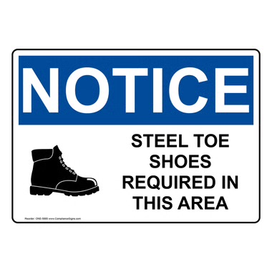
Ear protection is provided at the entrance to the department and is a requirement during production activity times. Please contact your production manager immediately if you require alternative hearing protection. | 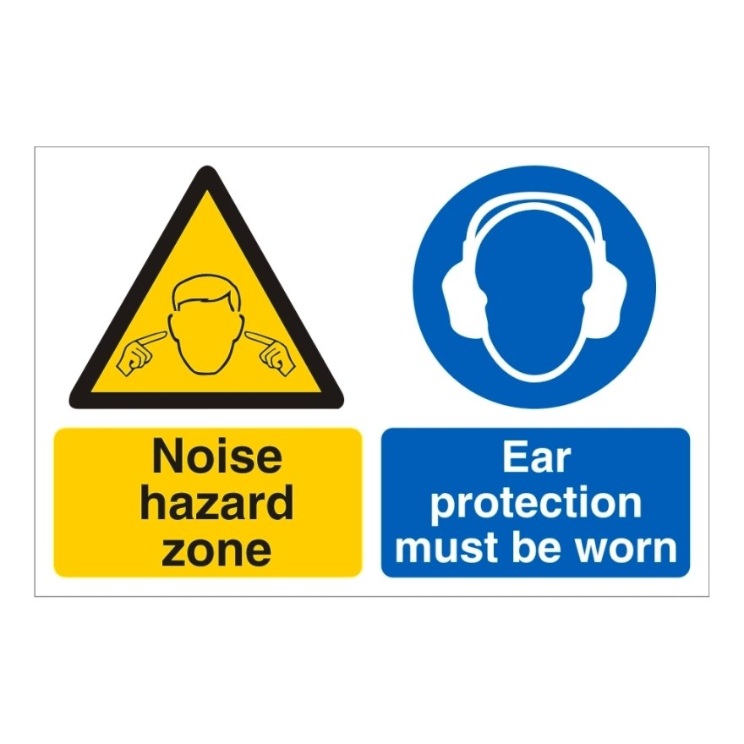

Key Purpose of The Procedure

The reel stands are the start of the production line in terms of the ruling machines. This is where paper reels are loaded into the machine and run at speed into the ruling tower to produce the ruling patterns required. There are four reel stands on RM7, with two of the stands running simultaneously (twin web) or running from one stand only (single web). The other reel stands are to prepare the next reels to run on to when the current one has run off. These reels require setting into position and preparing for the reel splice when ready. This procedure will guide you through the correct process to successfully operate the reel stands to standard. More visual details on how to operate the reel stands can be found in RM7 training plan level 1.

Preparing Reels

Make sure the correct equipment is available to ensure a safe operation. Ensure not to overfill the work area and use a powered reel truck to prevent any strains. Check for hazards and report to the nearest operator/manager before commencing operation.
- Check to ensure you are equipped for the reel preparation requirements e.g. snail, knife
- Check for the correct reel requirements and identify which reel is required. This can be found on the reel label (Good practice is to make a note of the size and length for after the reel is stripped).
- Remove all reel wrapping and check for reel damage, dispose of any bungs. Report any damage to the machine operator/manager.
- When running 2/4 reels, measure and match up the reel sizes so that waste is kept to a minimum
- Place all reel wrapping in the correct waste location
- Position the reels onto the yellow floor skates with the use of the electric reel truck.

Changing Reels

This section cannot be signed off fully until the trainee has had experience with operating a twin web and reels that run through the machine at a higher speed. Ensure hands are clear at all times when springs are compressing.
- When the horn sounds, the machine will automatically stop before the reel runs off
- Remove the waste reel core or part reel from the machine
- Press the up arrow to lift the arm to the top position
- Slide a new reel, on the yellow skates, into the reel stand and line it up between the rams
- Press the down arrow to line the rams up with the reel cores. Manually push the reel onto the far arm
- Press the right arrow until the springs compress (Ensure to keep hands clear of the springs)
- Press the up arrow to lift the reel slightly off the floor. Make sure to put air into the core chucks and the light is on the monitoring sensor (Ensure to use the reel and not the chuck to rotate when finding the air connection)
- Only strip off three layers/wraps of paper from the reel, unless the reel has any visible damage. Remember to report all damage to the machine operator/manager
- Press the right arrow and the black button together to complete the process

Making a Splice

As with changing reels, the training is not complete until the operator/trainer is confident that this operation has been completed to standard, at high speed and on twin web. The splice must be accurate or the end of one reel and the start of another will not form correctly and could cause web snaps, miss joins and increased downtime.
- Turn the air on to hold the paper in place. Thread the paper through the separate bar on the right hand side units only
- Line the paper up so it is parallel with the reel on the suction pads. Wind up the slack on the reel. Place knife in the top slit and cut off
- Use tape to the correct width required, trimming off any edges to taper the reel. Remember to remove the double sided tape before the next section
- Turn the brake back on (When the light is not on, the brake is not off)
- Press the right arrow and the black button on the other unit together. After a short delay the units will come together. Make the splice

